ACS-1809-004

Web Design and Development

Project Report

Student# : 3116318

 Student Name : Harshilkumar Vaghela

Date: April 10, 2020

**Introduction**

I don’t have any real organization in my consideration to build a website for therefore I am going to plan for a hypothetical retail store website in this assignment. I am naming it Something mart. It’s a retail store like Walmart, having products of different categories such as clothing, shoes, crockery, bed, bath, dairy& frozen food supplies.

**The Organization**

My hypothetical something mart is a newly opened grocery store in Winnipeg, Manitoba. Being a grocery store, the store has products of many categories. The store is already successful as there are a lot of customers already coming there. The store owner wants to grow their customer base and wants to provide more services to their customers and making a website is a best idea for that.

Store has many products of many categories. The list of categories goes like this:

1. Bedroom

2.Shoes

3.Clothing& accessories

4.Bathroom

5.Crockery

6.Dairy& frozen food

They will all be available on the website.

The store website offers quite a variety of options to their customers. The website shows the products which are available in the store with the details and price of those products as well as add them in cart. the customers can buy the product online for an in-store pick-up or delivery and can do the payment via credit card online.

The main purpose of the website is to reach more customers and provide services to the existing customers. The website allows customers to write feedbacks and to contact the customer service via phone calls or emails.

The store owner wills to hire more employees as the store is new, for that purpose, I am going to put recruitments on the website where the user can see the job posting and description and then can apply for that job and submit their resume with a message to the employer.

**Plan**

|  |  |  |  |  |
| --- | --- | --- | --- | --- |
| User group | Functions performed | Age group | Gender | Web Experience |
| Potential& Existing Customers | 1.Read the details of the company  2.Check the products available in the store and check prices and add them to cart  3.place order, select payment option and select delivery or in-store pickup option  4.manage their user account  5.be informed about hours and contact information | 15+ | M/F | Varies |
| Potential Employees | 1.View the job postings  2.Search for postings of specific position  3.Apply for the job  4.Contact HR | 18-60 | M/F | Varies |

Table 1-Functions performed by target audience

**Goals of the site**

* To reach out to more people and expand the customer base
* To hire new employees
* To increase the store sales
* To make it easier for customers to contact the store and give feedbacks

**Main topic areas**

* Home
* Shopping
* Account
* Reviews& Feedback
* Careers
* Contact
* Checkout

Note: Tree diagram is on the next page

**Tree diagram for the site structure**

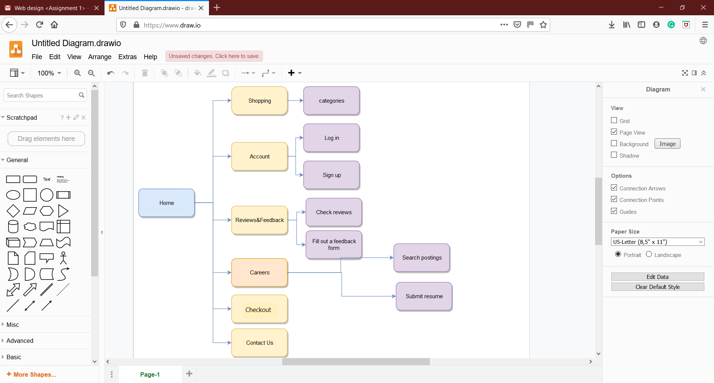

Diagram-1 Website structure

As we can see from the website diagram our website consists of five main topics. The first one is shopping which leads to categories. I will add the categories later in the navigation of the website. Basically, what shopping section does is that it takes the user to the categories and there are many different categories of the products there. Then in a specific category there are many products from which the user can add to cart, buy, make a payment and select delivery or pick-up option. Note that there are many subcategories in the categories.

The second is account in which user can sign up and log in by their email or phone number and password. The user can save their address for their products to be delivered. The third is feedback where users can check reviews given by other users and submit their own review in feedback. The fourth topic is careers. Here, potential employees can search for the posting of the job suitable for them and apply for the job. The fifth topic is contacts us where user can check the email or phone number of the store and last topic checkout in which user can make a payment of the items that they have added to their cart.

**Please Note**: I am adding button ***“Add to cart”*** for all the products which are supposed to be added in the checkout form, but as I don’t know about data handling I won’t be ***“actually adding”*** the products to cart when checking out. I hope I learn to do it in future.

**Content organization**

|  |  |
| --- | --- |
| subcategory name | Folder name |
| Bathroom | Shopping/bathroom |
| Bedroom | Shopping/Bedroom |
| Shoes | Shopping/shoes |
| Clothing& Accessories | Shopping/Clothing& Accessories |
| Dairy& Frozen | Shopping/Dairy& Frozen |
| Crockery | Shopping/crockery |
| Log in | Account/log-in |
| Sign up | Account/sign-up |
| Check reviews | Reviews/check-reviews |
| Fill a feedback form | Reviews/fill feedback |
| Search jobs | Careers/search jobs |
| Submit a resume | Careers/submit resume |
| Contact information | Contact us |
| Checkout | Checkout |

Table-2: Content organization

**Navigation**

The navigation of the website is already explained above in diagram and the website structure. The navigation bar will have six main topic areas shown in the tree diagram. This navigation bar will be consistent on all the pages of the website. The page user is currently surfing on will be highlighted. The title of the page will have the name as well to make it easy for the user to navigate.

**Special Features**

The product grid uses ***@media***, so if you turn your browser window size to smaller size, the number of products in one line will decrease proportionally to the decreased size. Check ***categories*** in ***shopping*** section for that. I have created a logo for the website as well. So that is you click on the logo, it takes you on the home page.

**Conclusion**

I have learned that how the websites are planned and then kept organized in the way that makes it easy and pleasant experience for the user to be visiting on the website, to keep the user on the website as long as possible. Having done this assignment, it will be easier for me to plan the website for any organization.

**References**

<https://courses.acs.uwinnipeg.ca/1809-004/Assignment%201.pdf>

<https://courses.acs.uwinnipeg.ca/1809-004/Assignment%201%20Template.doc>

<https://courses.acs.uwinnipeg.ca/1809-004/assign1%20sample.pdf>

<https://courses.acs.uwinnipeg.ca/1809-004/Chapter%202.pdf>